**DAILY ONLINE ACTIVITIES SUMMARY**

|  |  |  |  |  |  |  |  |  |
| --- | --- | --- | --- | --- | --- | --- | --- | --- |
| **Date:** | **11/07/2020** | | | | | **Name:** | **NIKHIL KUMAR** | |
| **Sem & Sec** | **4thSEM. & ‘B’ SEC.** | | | | | **USN:** | **4AL19CS400** | |
| **Online Test Summary** | | | | | | | | |
| **Subject** | | **NUL** | | | | | | |
| **Max. Marks** | |  | | **Score** | | |  | |
| **Certification Course Summary** | | | | | | | | |
| **Course** | Front-End Web UI Frameworks and Tools: Bootstrap 4 | | | | | | | |
| **Certificate Provider** | | | **Coursera** | | **Duration** | | | **4 week** |
| **Coding Challenges** | | | | | | | | |
| **Problem Statement1:--** Write a Java program for Reversal algorithm for array rotation by 3.  Given an array a[], array size n and d the number of index to be rotated task is to write a function rotate(arr[],d,n) that rotates arr[] of size n by d elements.  Example Input: n= 6 arr[]= {1,2,3,4,5,6} d=3 (specific) Output: arr[]= {4,5,6,1,2,3} | | | | | | | | |
| **Status: ---executed** | | | | | | | | |
| **Uploaded the report in Github** | | | | | **Yes** | | | |
| **If yes Repository name** | | | | | <https://github.com/Nikhil401/java-coding/blob/master/RotateArray.java> | | | |
| **Uploaded the report in slack** | | | | | **Yes** | | | |

**Online Training Summary : not conducted**

**Certification Course Summary: Today I have gone through the task1, task2 and task3 which is assigned as a “Assignment 1” shown in the snapshot….**

**Snapshot is given below** 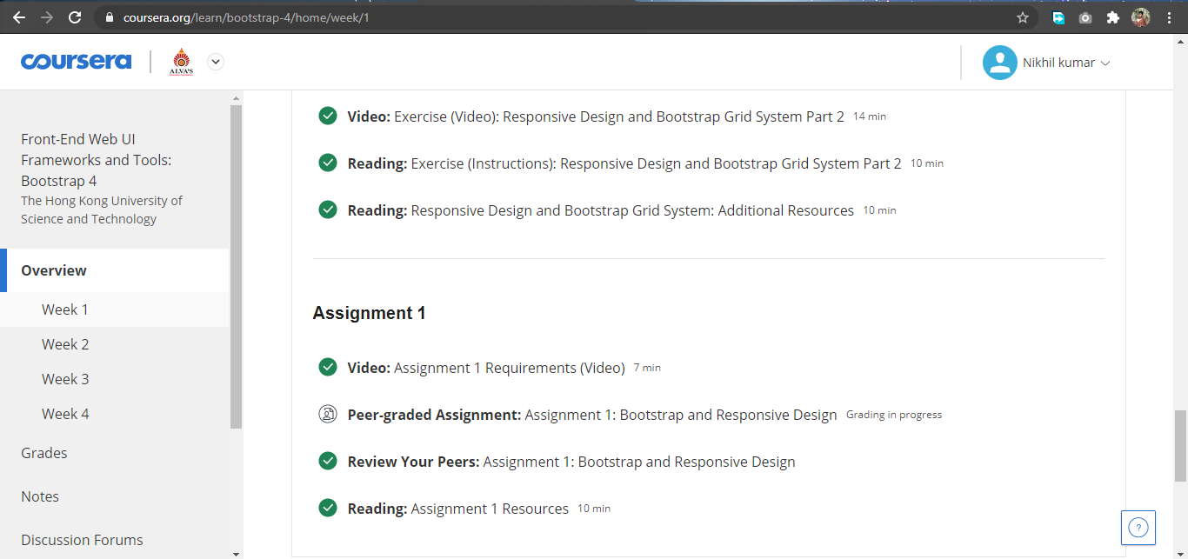

**Online coding summary: Today I had received programs which is mentioned in table above and I have uploaded into the github repository. Snapshot of the program is given below:**

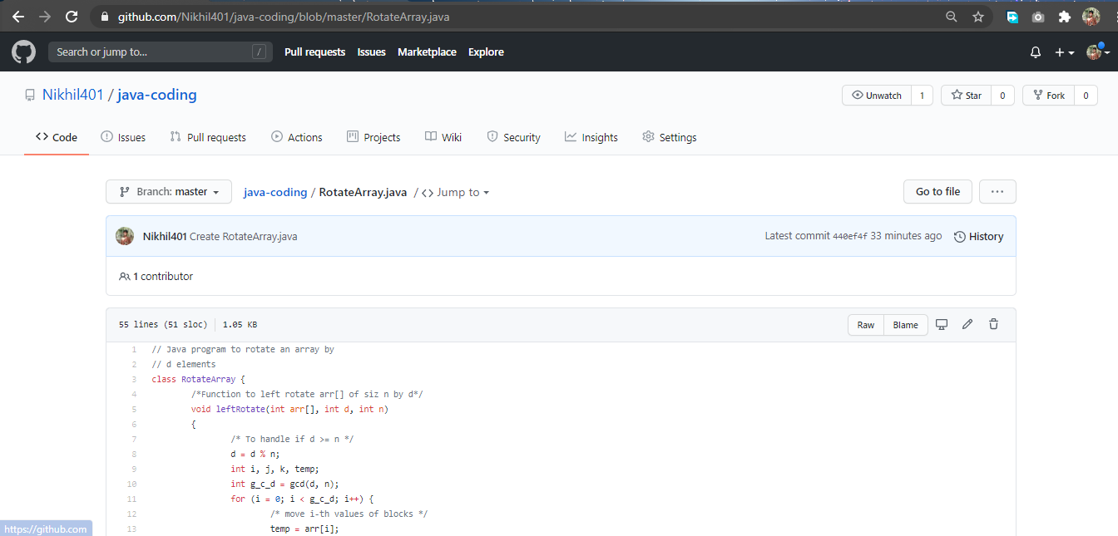

**Thank you.**